History of the Venomous Animals Research and Anti-Venom production Department

Abbas Zare Mirkabadi^{1*}, Hadi Rabiei²

- Venomous Animals and Anti-Venom Preparation Department, Razi Vaccine and Serum Research Institute.
- Agricultural Research, Education and Extension Organization, Karaj, Iran.

Abstract

Iran's diverse regional conditions make it home to a rich variety of animals and plants. This includes venomous animals such as snakes, scorpions, and spiders. The institute began exploring the possibility of preparing and producing antivenom serum in 1957. Initially, the snake research unit focused on collecting and identifying snakes from Iran and around the world to build an extensive collection. Later the Department was recognized by the World Health Organization (WHO) as a reference center for identifying venomous animals and producing antivenom. After successful production of polyvalent snake antivenom, due to repeated requests from Ministry of Health for scorpion antivenom to treat scorpion stings, the Venomous Animals and Antivenom Production department was given the additional responsibility of producing scorpion antivenom. In recent years, a new generation of staffs in this Department researchers has made significant advances by applying modern knowledge to research and production. Research efforts have focused on optimizing therapeutic serum production processes, increasing accuracy, and improving quality control techniques based on GMP principles. In 2025 a new polyvalent antivenom as Heptavalent was produced covering a new snake found in south east of Iran. This antivenom can cover all the snakes venom present in various regions of Iran as well as neighboring countries Currently, the Department is focusing its research on developing recombinant toxins which may be useful in production of specific antivenom as well as exploring the use of specific toxins to treat intractable diseases, such as cancer and multiple sclerosis

How to cite this article: Zare Mirkabadi A, Rabiei H. History of the Venomous Animals Research and Anti-Venom Preparation Department. Archives of Razi Institute. 2025;80(Special Issue):41-46. DOI: 10.32592/ARI.2025.80.Special Issue.41
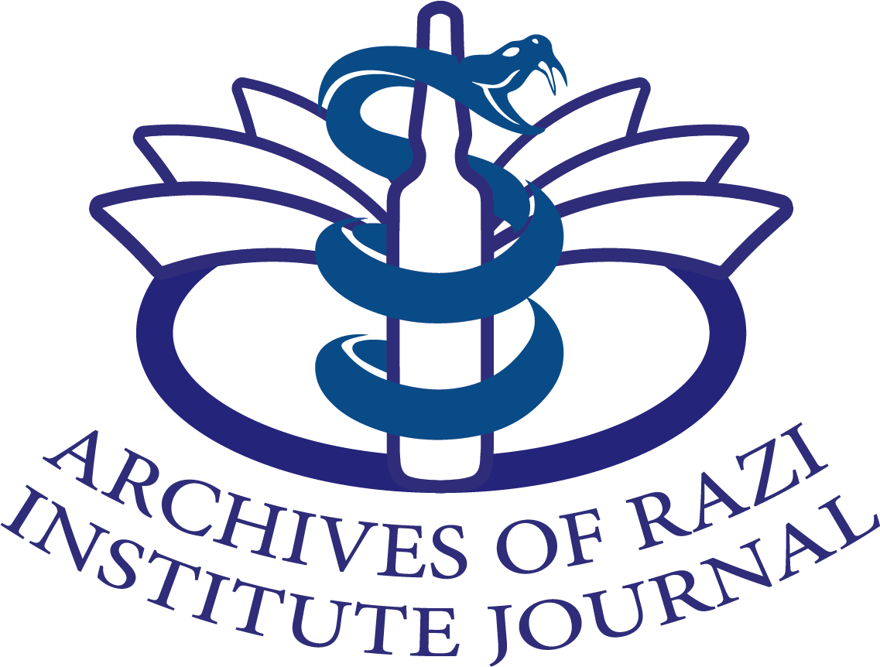

Archives of Razi Institute Journal

Volume 80, Special Issue, 2025

Journal homepage: https://archrazi.areeo.ac.ir
Iran's diverse regional conditions make it home to a rich variety of animals and plants. This includes venomous animals such as snakes, scorpions, and spiders. Historically, human bites from these venomous animals have posed a significant threat to public health. Several decades after the establishment of Razi Institute, which was the only authorized center for producing therapeutic serum in the country, the institute began exploring the possibility of preparing and producing antivenom serum in the second half of 1957. The institute decided to establish a venomous snake venom research and serum production laboratory to identify, classify, and extract venom milking from local and endemic snakes to achieve optimal results. In July 1960, the late Dr. Latifi realized this initiative, resulting in the establishment of a laboratory dedicated to studying venomous animals and venom production in Iran. Initially, the snake research unit focused on collecting and identifying snakes from Iran and around the world to build an extensive collection. They also published numerous books and articles on the subject. Training skilled personnel in collecting, maintaining, feeding, and extracting venom milking from snakes was also emphasized, highlighting the importance of specialized staff in this field. During this period, 20 milligrams of cobra venom and 13 milligrams of Macrovipera lebetinus (blunt-nosed viper) venom were milked and lyophilized and prepared. In 1962, venom milking was extracted carried out from two types of venomous snakes: The Central Asian cobra and the Macrovipera lebetinus (blunt-nosed viper). The divalent serum was produced.
By 1963, the snake research laboratory had been upgraded to include units for producing serum and venom. Thirty-three species were identified, and a polyvalent serum was produced against four native Iranian venomous snake species. This serum was then provided to health organizations. Additionally, monovalent serum was prepared for each species of snake to treat potential bites among the staffs. In 1964, research and studies in this department snake research department expanded, and the findings were published in several articles at international congresses. The number of identified snake species increased to 50, and a valuable collection of snakes from Iran and around the world was established. Furthermore, this year marked the beginning of Iranian scorpion studies in collaboration with Dr. Farzanpay. Several scorpion samples were collected from different regions of the country.
In 1965, the department was renamed the Venomous Animals and antivenom Production Department. New personnel were recruited, and research, study, along with and production activities were expanded. These activities included increasing the polyvalent serum to include nine snake species and collecting and identifying twelve scorpion species from various regions. For the first time, a team was sent to various regions for studying venomous reptiles.
In 1966, two articles were published: one titled "Venomous Snakes of Iran" and another on the preparation of antivenom serum. This year also marked the first time that venom milking was carried out from scorpion samples.
In 1967, the venomous snake Vipera latifi was identified and named in honor of the late Dr. Latifi.
The following year, the common properties of snake venom in Iran were studied, and three scientific articles were published on antivenom serum, Iranian scorpions, and venomous snakes in Iran.
Following improvements in the quality of the polyvalent antivenom serum produced at the Razi Institute, as well as numerous international research publications by its scientists, the Venomous Animals and antivenom Production Department was recognized by the World Health Organization (WHO) as a reference center for identifying venomous animals and producing antivenom serums. Consequently, the institute's antivenom was exported to neighboring countries and larger quantities were produced for export.
During this time, due to repeated requests from Ministry of Health centers, especially the Army Medical Corps, for scorpion antivenom serum to treat scorpion stings, the venomous animals and Antivenom production department was given the additional responsibility of producing this antivenom. Consequently, the study of Iranian scorpions intensified, though effective antivenom serum against scorpion stings was still far off.
In 1970, after ten years of continuous efforts by researchers and staffs in the Venomous Animals and Antivenom Department, a new building was completed and became operational. Activities entered a new phase with improved facilities and new equipment.
The new building included a dedicated section called the Scorpion Research and Antivenom Serum Production Laboratory focused on studying Iranian scorpions. This section's primary activities consisted of zoological research and limited venom extraction from scorpions.
In 1971, a simpler form of the gel diffusion technique was adopted, and a research paper titled A Comparative Study of Venoms of Iranian Snakes was published. Another article examined the characteristics of various snake venoms through extensive testing conducted across different seasons and regions. The testing included individual and group venom extraction as well as comparisons of male and female snakes and left and right fang bites. The obtained venom was analyzed using in vivo and in vitro methods. In 1972, mealworms were bred by multiplying a species of insect called Tenebrio molitor. These worms were used to feed scorpions. In 1975, the first identification key for Iranian scorpions was developed in cooperation with Professor Vashon from the Natural History Museum in Paris.
In 1977, an effort was made to produce large scale antivenom serum for scorpion bites. A total of 5.6 liters of anti-scorpion serum was obtained by immunizing ten horses. However, this volume was insufficient to meet internal demand. Serum was still imported from abroad. Various tests were conducted on these imported serums, including in vivo and in vitro assessments, to determine the potency of the antivenom. However, satisfactory results were not achieved, and the imported antivenom lacked adequate therapeutic value.
Over the following years, production, research, and diagnostic activities continued to grow. By 1985, production of antivenom serum against snakes had reached 112 liters, while production against scorpions had increased to 43 liters.
In 1989, scorpion envenomation became a major public health issue in Khuzestan Province, particularly from a species of scorpion called Hemiscorpius lepturus, belonging to the genus Hemiscorpius. The anti-venom serum for scorpion envenomation was primarily produced using venom extracted from the venom glands of scorpions. This process revealed the necessity for further research.
From 1990 to 1992, field studies on the biology and ecology of scorpions were conducted in southern Iran as part of a research project. Later, a national project studying Iranian scorpions was implemented, producing the following results:
• Identification of over fifty major scorpion habitats and training of several local hunters.
• Collecting sufficient quantities of scorpions, especially dangerous species such as Androctonus crassicauda,

Hemiiscurus lepturus, Hottentotta zagrosensis, and Hottentotta saulcyi.
• Venom milking from scorpions using electroshock.

Between 1993 and 1995, new worldwide methods for producing snake and scorpion antivenoms were leveraged to develop indigenous antivenoms for Iran using venom from electrically stimulated scorpions, including both complete and incomplete adjuvants. Using purified venom and adjuvants reduced the volume of venom required per immunization cycle for snakebite serum from 220 mg to 70 mg and for scorpion antivenom from 220 mg to 40 mg. Additionally, the number of injections per immunization cycle decreased from 10–12 to five.
Consequently, the neutralization rate in anti-snakebite serum increased by around 50%, and in anti-scorpion serum by over 200%. These changes led to a significant increase in antivenom production in the 1990s compared to the 1980s: around a 100% increase for snakes and a 500% increase for scorpions. In 2001, production of polyvalent antivenom for snakebites began using Cobra (Walterinnesia) venom to strengthen hexavalent snake antivenom.
In 2004, a major project was launched to renovate the department building. Designed by specialists, the building was completed in 2008 and complies with standards. Since 2008, releasing venom-extracted snakes from the department's facilities has been part of the Venom Department's operations. These operations are carried out in collaboration with environmental organization officials and experts. During 2006 to 2011, extensive research carried out in relation to identification and characterization of various species of snakes and scorpion venoms using high techniques like HPLC and Mass spectroscopy leading to identification of peptides which may be used in treating cancers and Multiple sclerosis In 2011, the department conducted the first experience in capture release venom milking of snakes (Echis or saw-scaled viper — Qaen) at the capture site and the subsequent release of the snakes in the same area.
In 2012, after the department's officials, experts, and the institute made persistent efforts and department received the Ministry of Health's approval for pentavalent snake antivenom and this new antivenom was added to the department's product line. Since then, the production of snake antivenom has approximately doubled. Since 2019, the department has begun researching and making efforts to breed and maintain venomous snakes used in antivenom production, and these efforts are ongoing. Notably, the growth trend in this department has occurred quantitatively and qualitatively. The increase in therapeutic serum production reflects the continuous efforts of researchers and staffs. In recent years, a new generation of venom department researchers has made significant advances by applying modern knowledge to research and production. Recent extensive studies have focused on the physicochemical and biological properties of certain venoms. Research efforts have focused on optimizing therapeutic serum production processes, increasing accuracy, and improving quality control techniques based on GMP principles, which are part of the department’s research and production activities.
In 2025 a new polyvalent antivenom as Heptavalent was produced covering a new snake found in south east of Iran. This antivenom can cover all the snakes present in various regions of Iran as well as neighboring countries. Currently, the Department is focusing its research on developing recombinant toxins which may be useful in production of specific antivenom as well as exploring the use of specific toxins to treat intractable diseases, such as cancer and multiple sclerosis. Given the department's existing capabilities, one of our goals is to regain reference laboratory status in toxinology, as recognized by the World Health Organization.

The department's academic achievements over time include:
• Publication of over ten specialized scientific books on snakes, scorpions, and toxinology
• Publication of over 150 scientific articles in international journals
• Hosting dozens of workshops on venoms and antivenoms
• Updating and improving first aid methods for envenomation

Heads of the department:
• Late Dr. Mahmoud Latifi from the beginning until 1991
• Dr. Abolfazl Akbari (1991-2005)
• Dr. Abbas Zare Mirakabadi from 2006 to 2011
• Dr. Abolfazl Akbari again, from 2012 to 2014
• Dr. Naser Mohammadpour from mid-2014 to mid-2024
• Dr. Abbas Zare Mirakabadi, from mid-2024 (1403) to the present

References

1-The Lizards of Iran, Stevens c Anderson, Soc. for the Study of Amphibians and Reptiles, Oxford (OH, USA).1999.
2- Iranian veterinary society journal , : Vol,8(20) 2007.
3- . Mahmood latifi, Iranian Snake book. Edited and published by. Environment Organization of Iran
4-Latifi M. Variation in Yield and Lethality of Venoms From Iranian Snakes. // Toxicon., 1984,
v. 22, № 3, p. 373–380.
4- Latifi M., Shamloo Kd., Amin A. Characteristic Electrophoretic Patterns of Serum Proteins of
Several Species of Snakes of Iran. // Can. J. Biochem., 1965, v. 43, p. 459–461
5-Latifi M. The Snakes of Iran. Society for the Study of Amphibians and Reptiles. Oxford, Ohio,
USA, 1991.
6- MH Motedayen, G Nikbakht Brujeni, MJ Rasaee, A Zare Mirakabadi, .Production of a Human Recombinant Polyclonal Fab Antivenom against Iranian Viper Echis carinatus Archives of Razi Institute 73 (4), 287-294
7- B Masihipour, A Zare Mirakabadi, H Rabiei, A Hedayat Cross-reactivity and neutralization capacity of polyspecific antivenom produced by Razi institute against three species of buthidea family scorpions.
Asia Pacific Journal of Medical Toxicology 8 (3), 90-94
Mohammad Ali Bayatzadeh1 · Abbas Zare Mirakabadi2 · Nahid Babaei1 · Abdolhassan Doulah3 · Abbas Doosti. Expression and purification of recombinant alpha-toxin AnCra1 from the scorpion Androctonus crassicauda and its functional characterization on mammalian sodium channels. Molecular Biology Reports. doi.org/10.1007/s11033-021-06624-2

